System Model

Network Model
Sensors are randomly deployed in an area. There is one sink. All nodes are static. Application can subscribe events from the sink. The network can be modeled a graph G=(V, E) where V represents the sensor nodes and E represents the communication links.

Basic Assumptions
We assume that the event definition will be processed with the following information available:
- Events: E={e1, e2, …en}
- Event Relationships: R={em -> en| em, en ∈ E}

Event Model
An event is a set of attributes each with a value and a type that reflects certain phenomenon over a period of time in certain region where the time and region are both expressed as attributes of the events. Events can be applied to user-defined filters which are used to determine a certain event needs to be delivered to the user or not.
Event Filters
Filters are constraints on the attributes of certain event. Event relationships can be expressed as a set of operators on the event attributes. In this report, we consider how we can efficiently detect events based on their temporal and spatial relationships so the time and coordinate attributes will be of most interest. We model the event filters as follows:
Each filter consists of a set of predicates combined by logical operators. Each predicate has the following characteristics:
- It operates on the same type of attribute
- It has the following syntax: e1.a (op) e2.a (op) e3.a … (logic) constant. Where op is one of the following operators: +,-,*,/ and logic is one of the following operators: =,>,<,>=,<=
Event Temporal Relation
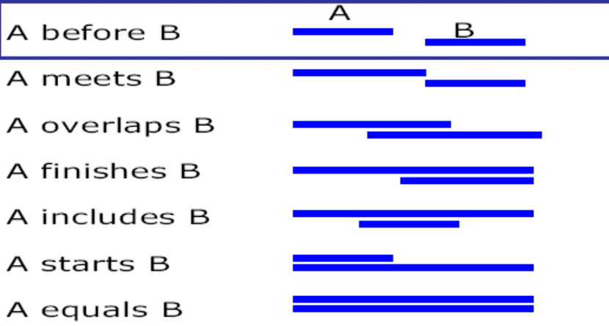
In summary, all the above event relationship can be expressed in terms of the start time and end time of the two events.
Event Spatial Relations
We assume the events’ locations are not known in advance but we know their relative locations. For example, if we have 2 events with overlapping relation as following:
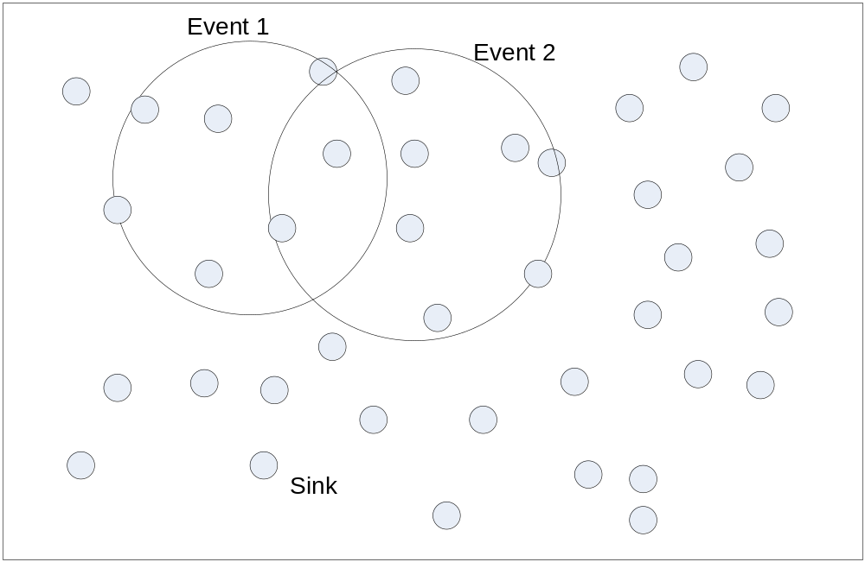
However, the two events can appear anywhere in the network such as:
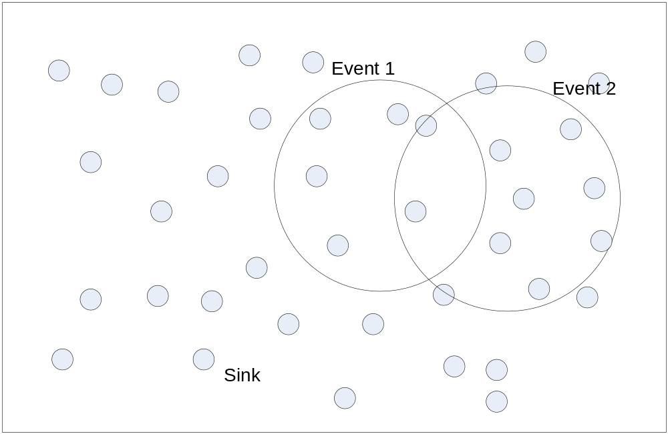
In this report, for simplicity, we define the event relation with the following model:
e1.a (op) e2.a (op) … en = c
Where (op) is of the operator + or -, ei is the event and c is the constant

Basic Idea
The protocol is an extension to the double ruling protocol. It makes use of the spatial and temporal relations of the events and efficiently disseminates the event detection results. The basic idea of the protocol is to store the event detection results in an energy efficient manner so that events can be detected. The protocol can be divided into two parts according to the spatial relation of the events.

Spatial Relation on X Coordinate
First, if two events have the relation on their y coordinate attribute, then when the sensor nodes detect one event, the result can be stored along the can be stored along the x coordinate and the other one can be stored along the y coordinate so that it will be guaranteed to meet at certain part of the network. For simplicity, we can store the event with smaller ID on the x coordinate and the one with larger ID on the y coordinate.

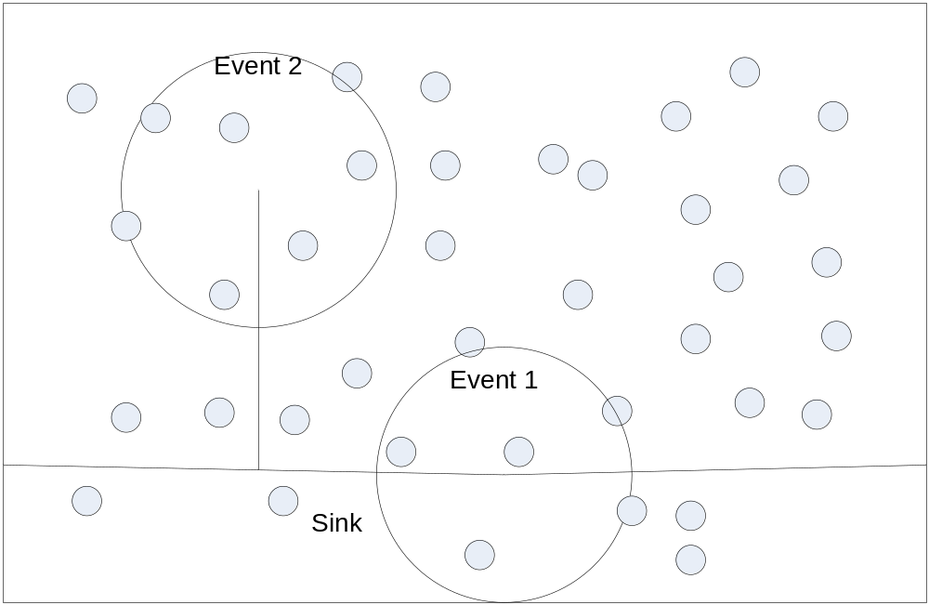

Spatial Relation on Y Coordinate
Similarly, when two events have relation on the x coordinate the event detection results can be stored along the x coordinate. Here we can also let the event with smaller ID to store the results on the y coordinate and let the other one to store the event on the x coordinate.
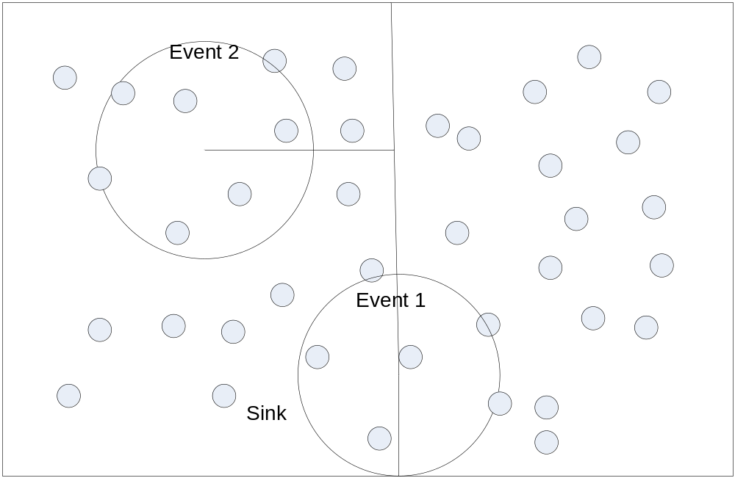

Combination of the Two Cases
When the two events have combined relationships, we don’t have to store the results on all of the coordinates. As shown in the following case:
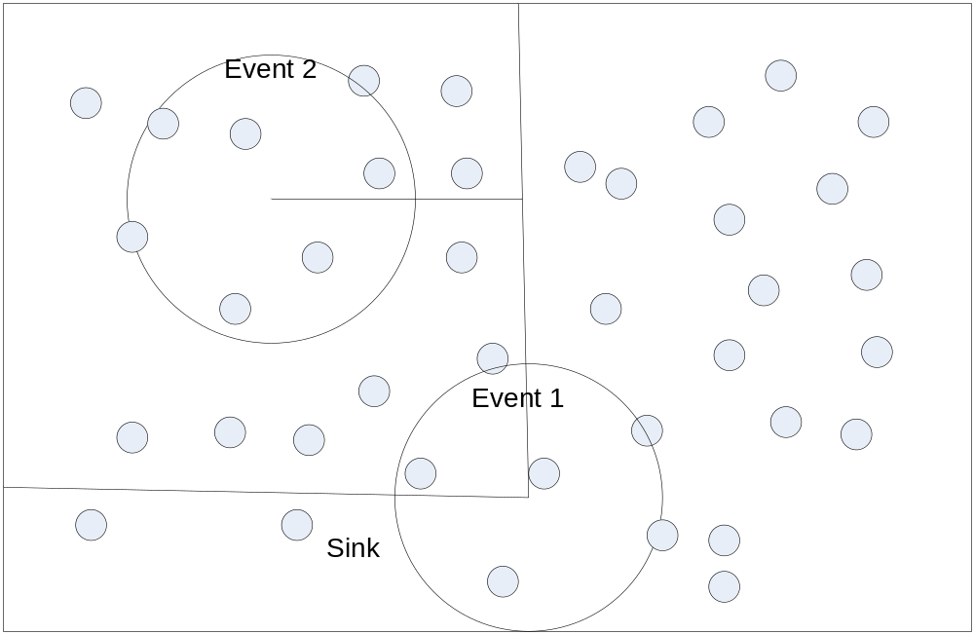
The protocol can be summarized as follows:
- E1 & E2 with X relation only:
 | X | Y
Event 1 |  | Entire Y
Event 2 | Entire X
- E1 & E2 with Y relation only:
 | X | Y
Event 1 | Entire X
Event 2 |  | Entire Y
- E1 & E2 with both relation:
 | X | Y
Event 1 | Part of X | Part of Y
Event 2 | Part of X | Part of Y

Pseudo Code
Based on the above cases, we can have the pseudo code:
EventDetected (En) {
for (all pairs of r_{i} in R) {
if (exists (r_{i}=(e_{n}.x, e_{m}.x))) {
addPath (e_{n}, y)
}
if (exists (r_{i}=(e_{n}.y, e_{m}.y))) {
addPath (e_{n}, x)
}
if (exists (r_{i}=(e_{n}.x, e_{m}.x)) and exists (r_{i}=(e_{n}.y, e_{m}.y))) {
if (e_{n}.x < e_{m}.x & e_{n}.y < e_{m}.y)
removePath (-x, -y)
else if (e_{n}.x < e_{m}.x & e_{n}.y > e_{m}.y)
removePath (-x, +y)
else if (e_{n}.x > e_{m}.x & e_{n}.y < e_{m}.y)
removePath (+x, -y)
else if (e_{n}.x > e_{m}.x & e_{n}.y > e_{m}.y)
removePath (+x, +y)
}
}

Optimization
The protocol can be further optimized if we take the sequential relations of the events into considerations and use a regional flooding. For example, if event 1 happens before event 2, we can use a regional flooding to inform the nodes which will be detecting event 2:
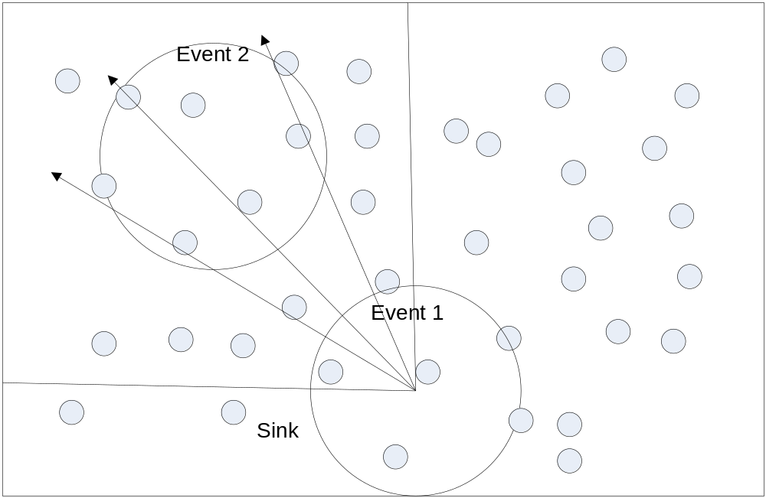
In order to make such a decision of whether to use flooding or not, the nodes need know the cost in detecting Event 2 and the flooding region. Assume the cost for detecting event 2 is C1 and the flooding cost is C2. The probability that event 2 will happen is p. Then the flooding decision should be made when:
C1*p<C2

Problem Formulation
Given:
- A network G=(E,V)
- A set of events E={e₁, e₂, … e_{n}}, one of the event e_{s} is subscribed
- A set of event filters F={f₁, f₂, … f_{n}} for the events.
- Each of the event filter has the following format: e₁ op e₂ = c where e1, e2 ∈E, op is any of the following operator: +,-,*,/ and c is any constant
Objective:
The network will try to detect the subscribed event e_{s} for the user. It will detect any event e_{n} ∈E. Upon detecting e_{n}, the sensor nodes will disseminate the detected information in the network in order to detect other event. The objective is to minimize the total cost (defined as below) so that e_{s} will still be detected

Assumptions
A few assumptions need to be made before introducing the cost functions and the algorithm:
- The sensor nodes knows it’s location
- Event locations are not known in advance but their relative locations are known. This is obtained through the event operators defined above.

Cost Functions
There are three cost functions in the problem:
- Cost to detect an event e_{n} (C₁). The cost can be viewed as the weight of the minimum spanning tree within the event:
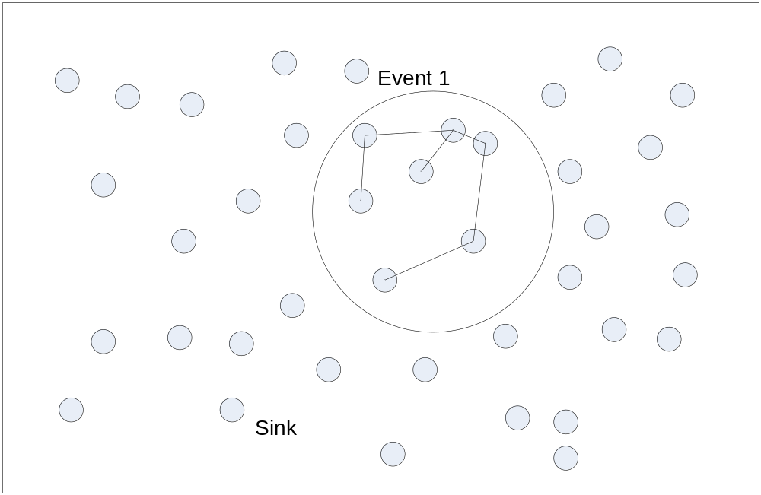
- Cost to disseminate the event detection result of e_{n} (C₂). This cost depends on the target region of the dissemination. The cost is shown in the following diagram (in this case, the event detection result is disseminated to the sink):
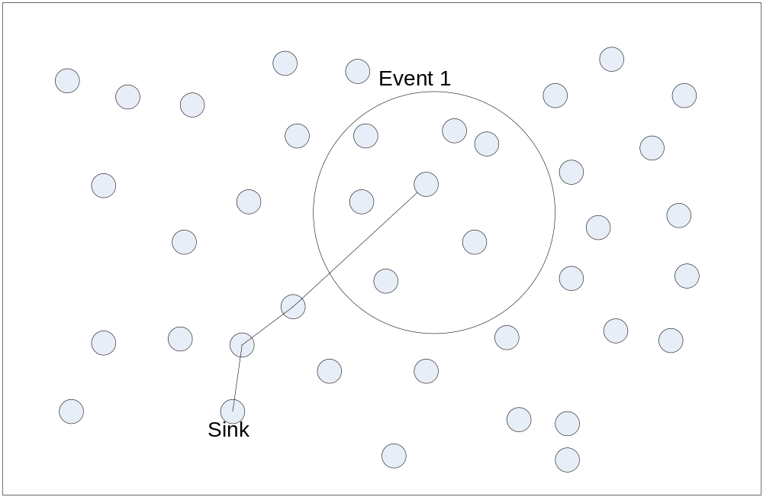
- Cost to reach the event detection result (C₃). Other nodes will eventually need to find the event detection result disseminated earlier and cost will occur as nodes are sending messages in the network when trying to find the results. The following diagram shows and example when event 2 needs the detection result of event 1:
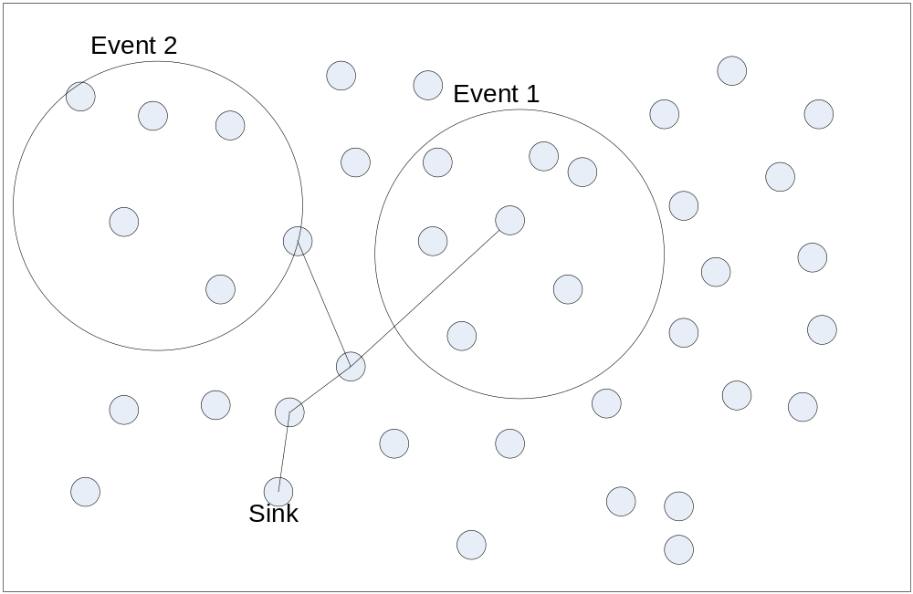

Event Detection Algorithm
We first consider the ‘–‘ operator when detecting two events e₁ and e₂. Before giving the algorithm in details, let’s give the following notation and assumptions:
- The network diameter is D
- C(e_{n}) denotes the cost of detecting event e_{n}
- e₁.x-e₂.x<=c₁
- e₁.y-e₂.y<=c₂
- The network detects e₁ first and then e₂. Since e1 will be detected first no matter what approach is used, we will focus on e₂ when calculating event detection cost.

Approach 1: Controlled Flooding
Since the nodes don’t need to detect e₂ before the detection results are received.
C₁=0
C₂=c₁*c₂+1
C₃=0
Total cost: C_{total}= c₁*c₂+1
The situation is illustrated as follows:
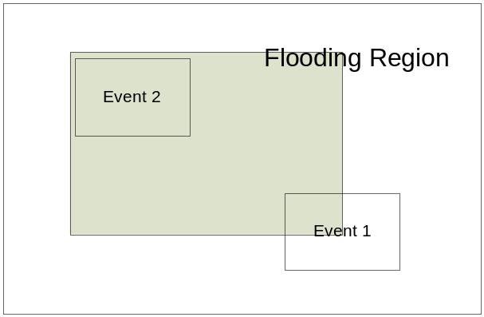

Approach 2: Double Ruling
C₁=C(e₂)
C₂=D
C3=D
Total cost: C_{total}= C(e_{n})+2D
The situation is illustrated as follows:
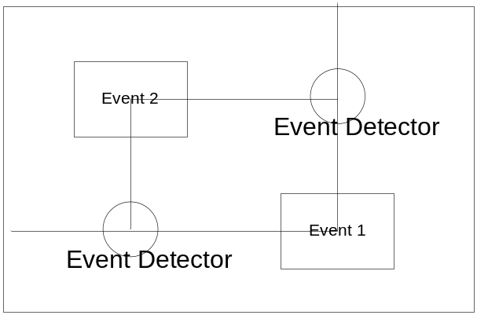

Cost Analysis
The above cost estimation is done based on the assumption that the two events are not detected in the same time. If the two events cannot be detected in such kind of sequential order, then double ruling approach has to be used to detect the events. Essentially, the difference between the two approaches is the difference between the cost of flooding (c₁*c₂+1) and the cost of detecting event 2 (C(e₂)). If the flooding cost is smaller, the first approach should be used. Otherwise, the second approach should be used.

Event and Subscription Model
Each event contains a set of attributes where each attribute has a type, an identifier and value (type, id, value). It has all the raw data obtained from the sensor node.
Subscription contains a list of distinct pairs of event topic and its corresponding filter.
- Topics: each topic contains a set of attributes (type, id, value) wanted by the subscriber. These attributes can be a subset of the attributes directly obtained from the event or it can be indirectly obtained through a set of operators and functions. It is used to represent the event wanted by subscriber.
- Event filters: each filter is an expression which operates on the attributes used in event topics.

Event Topic
Each event topic is an abstraction of the event obtained by the sensor nodes and of subscriber’s interest. Since it’s the subscriber’s view of events, we will simply use the term ‘event’ to denote the event topics defined in the subscriptions. Event topic can be mapped to simple events which can be directly obtained by the sensor node or it can have some attributes which needs to be obtained by processing the raw data from the sensor node. The processing can be:
- Aggregate functions: average(), sum(), median()
- Operators: + - * /

Event Filter
Event filter can be expressed as one of the follows:
- f (e_{n}, e_{m}) = e_{n}.attr – e_{m}.attr op c
- f(e_{n}) = e_{n}.attr op c
e_{n} and e_{m} are two sub events and c_{p} is the composite event, c is a constant and attr is an attribute of the event and op is one of the following logical operators: >, <, =, <=, >=. We use f(e_{n}, e_{m}) and f(e_{n}) to denote the above filters.
Each event topic has a set of filters. The whole subscription can be expressed as follows:
- c_{p1}: f₁(e_{a1}, e_{b1}) f₂(e_{a2}, e_{b2}) … f_{n}(e_{an}, e_{bm})
- c_{p2}: f₁(e_{a1}, e_{b1}) f₂(e_{a2}, e_{b2}) … f_{n}(e_{an}, e_{bm})
- …
- c_{pn}: f₁(e_{a1}, e_{b1}) f₂(e_{a2}, e_{b2}) … f_{n}(e_{an}, e_{bm})
Here c_{x} is the composite event and the rest of the events e_{x} are sub-events. On each of the line, all the filters are of ‘and’ logical relations. Between any pair of the line, the filters are of ‘or’ logical relations. A few rules are needed to ensure the correctness of the subscription:
- On each of the line, c_{p} won’t appear in any of the filtering functions following it.
- There can be multiple lines of the same event c_{p}, which is used to express an ‘or’ logical relation.

Expressing Relations with the Model
We can use the described event and subscription model to express important relations such as temporal, spatial and logical relations of the events.

Temporal Relations
It can be shown that the above event model can be easily used to model the following event temporal relations
We can also show that event logical relations can be expressed by the above model.
- Before: e_{a}.end<e_{b}.start
- Meets: e_{a}.end=e_{b}.start
- Overlaps: e_{a}.end>e_{b}.start
- Includes: e_{a}.start<e_{b}.start and e_{a}.end>e_{b}.end
- Starts: e_{a}.start=e_{b}.start
- Euqals: e_{a}.start=e_{b}.start and e_{a}.end=e_{b}.end

Spatial Relation
Spatial relations usually implicitly indicate temporal relations. A pure spatial relation (without any temporal) can be denoted as follows:
- s(e₁, e₂)
- s(e₁)

Expressing Logical Relation of the Events
The logical relations can be expressed by having the same cp on multiple lines in the subscription. For example:
- C₁: f(e₁, e₂)
- C₁: f(e₂, e₃)
Indicates the composite event c1 can happen under two conditions: when e₁ and e₂ satisfy a certain relation or e₂ and e₃ satisfy a certain relation

Event Detection Using Temporal and Spatial Relation
A few rules can be used to help detect events with the above defined spatial and temporal relations:
- If there is a filter s(e1), the node can use it to evaluate it. If the result is false, then the node doesn’t have to participate in detecting this event. That filter entry can be deleted from the local node.
- If there is a filter s(e1), and the evaluation result is true, then the node needs to send this information to other nodes.
- If there is a filter t(e1, e2) and the node receives information from another node about its capability of detecting e1 or e2, then it will set up the forwarding path to that node.

Event Detection
Events are detected in a bottom-up fashion. Sensor nodes will first monitor the primitive events. Upon the detection of these events, they will use the filters to monitor the composite events.

